Having trouble viewing this email? Click here



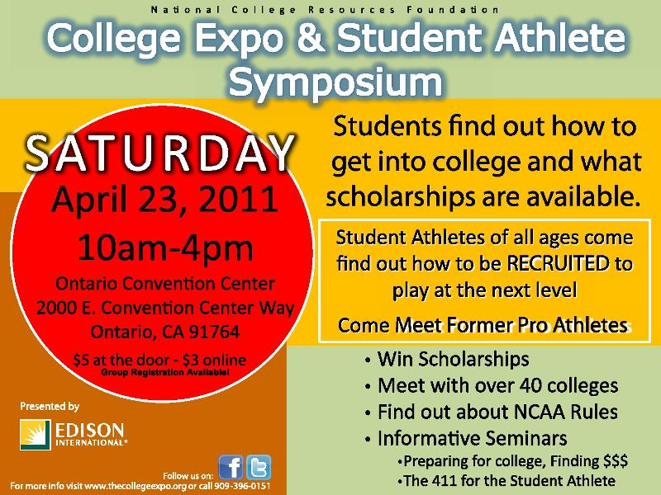
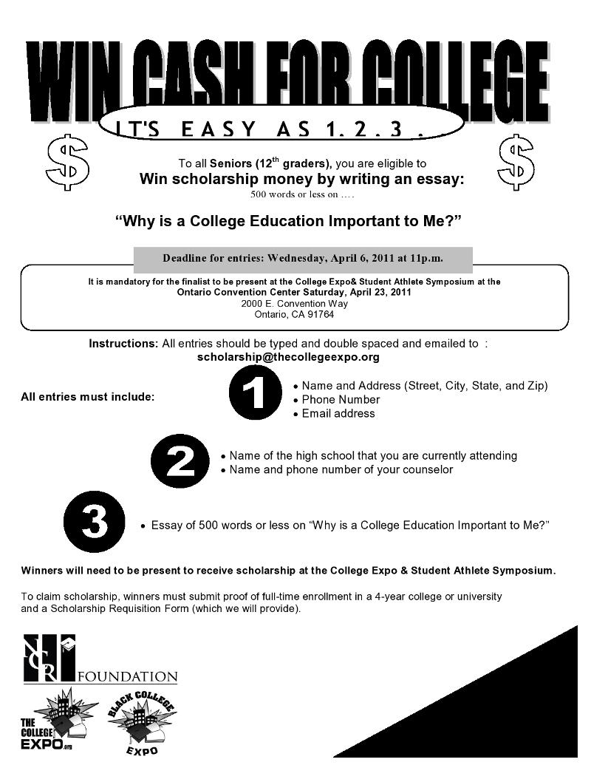
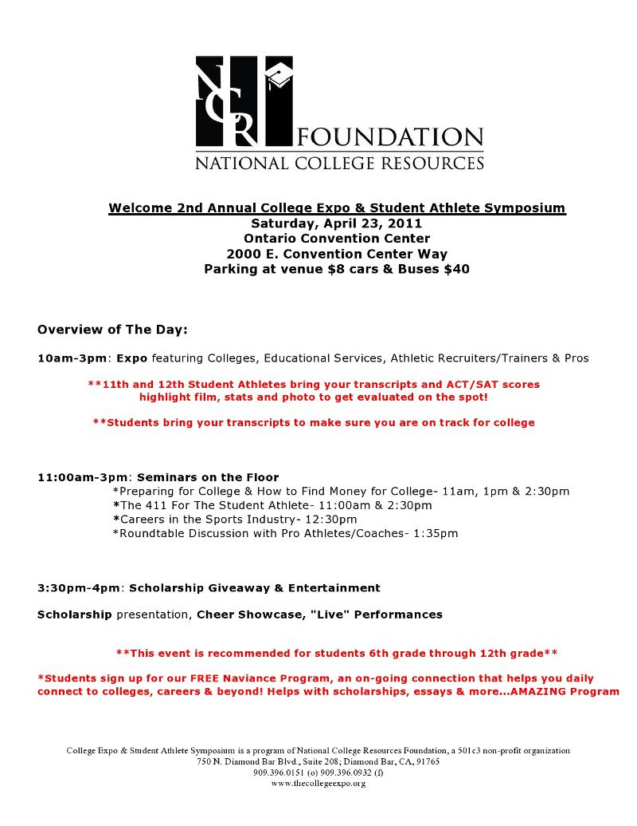

Join Our Mailing List!
Stay Updated on Internships, Jobs, Scholarships & More!
Click the link to "Stay Connected"
http://www.thecollegeexpo.org/tce/index.php?option=com_chronocontact&Itemid=100006

www.thecollegeexpo.org
We are a Non-Profit 501C (3) Organization

Forward email

This email was sent to jscudellari@pylusd.org by veronica@jabez3.com |
Update Profile/Email Address | Instant removal with SafeUnsubscribe™ | Privacy Policy.
National College Resources Foundation | 750 N. Diamond Bar, Suite 208 | Diamond Bar | CA | 91765

